Business Analysis

CS39930 – Web Based Major Project

Ryan Jones – RYJ7

Contents

Introduction 3

Stakeholders 3

Users And Use Cases 4

User 1 – Lucia, 22 (Client) 4

User 2 – Bill, 39 5

User 3 – Greg, 32 5

User 4 – Margret, 57 5

Use Case Diagram 6

Login, Create Account and Log Out. 6

Edit Recipes 6

Make Shopping List 7

Delete User 7

Browse Recipes 7

Change Password 7

Related Materials 7

BBC Food 7

Simply Recipes And Relish 9

Allrecipes 10

References 12

# Introduction

The web-based project that I have decided to build is a meal planner that allows the user to look through recipes created by themselves and their close friends and family to add to this planner. There will also be an option to create a shopping list from the recipes selected in the weekly planner.

The customers/users of this site are my close friends and family to allow them to share recipes efficiently and in a clear format as well as making them easily accessible. The customer also wants to ensure that meal planning and shopping trips are efficient.

The people that want to be built will be the users/customers as it is for people who are interested in cooking as well as wanting to share the recipes with their friends.

# Stakeholders

The rich picture below shows the different interactions that the website has when it is used (figure 1). It covers each of the functions of the site as well as the external factors such as getting the food and the power to houses that the users live in.

Figure 1. Rich picture of the environment that the system will be working in.

Figure 1 shows the two possible users of the site. These types of users can be the same person that wants to add their own recipes and add them to their meal planner. These users can create recipes and then select the recipes then add them to their planner.

The recipes are all stored in a database that can be added to a planner table that stores up to seven recipes (the seven days of a week). If there are any recipes in the planner a shopping list can be made which gets all of the ingredients from the recipes in the planner and puts them in a large list.

# Users And Use Cases

## User 1 – Lucia, 22 (Client)

Lucia is 22 years old and is a university student that likes to share pictures of the food she makes and how to make them with her family. She also likes to make a plan of what she would like to have for dinner that week so she knows what to buy to try and save money and waste less food. Many of the meals she makes are ones that she has been taught to make by her mum but she sometimes forgets some of the steps.

Do you plan your meals on a weekly basis? If so, how do you plan them and what tools do you use?

*Yes, I plan my meals using the notes on my phone and by checking what ingredients I already have.*

Do you write a list before you go shopping? If so, where do you write the list?

*I do write a list, on my notes app.*

Do you share recipes with friends and family? If so, how do you share them?

*Me and my family normally share recipes by sending the websites where we found them to each other.*

If there was a way to share recipes with your friends and family online, what things would you expect to see or would want to see on it?

*It would be good to have all the recipes in one place, either a website or app so they are easy to find. It would be interesting to be able to know what our friends or family have tried to make.*

*Also, it would be good to have a list of the ingredients needed in a way that would be easy to add them to our shopping lists.*

## User 2 – Bill, 39

Bill is 39 years old and is part of a healthy eating group where they share their newly found healthy recipes with each other to try. It is fairly easy for Bill to share his recipes as he writes them down and passes them on to the people he wants to share them with. Bill also likes to bake and enjoys trying to recreate takeaways at home.

## User 3 – Greg, 32

Greg is 32 years old and likes to plan his meals and make his shopping trips as efficient as possible as he is very busy on weekdays and likes to spend his weekends away with his dog. Greg uses the built in notes app on his phone and has to think about the meals and the ingredients needed to make the meals before he goes shopping which can take up a large amount of time.

## User 4 – Margret, 57

Margret is 57 years old and loves to cook. She likes to share recipes she’s made with friends on WhatsApp but the recipes get lost in the chat as people send messages. Margret also keeps some of her older recipes in a book that is almost full and has had liquids spilled on it many times meaning some of the recipes are lost and thinks that if she could access them all from her tablet or phone it would make her life a lot easier.

## Use Case Diagram

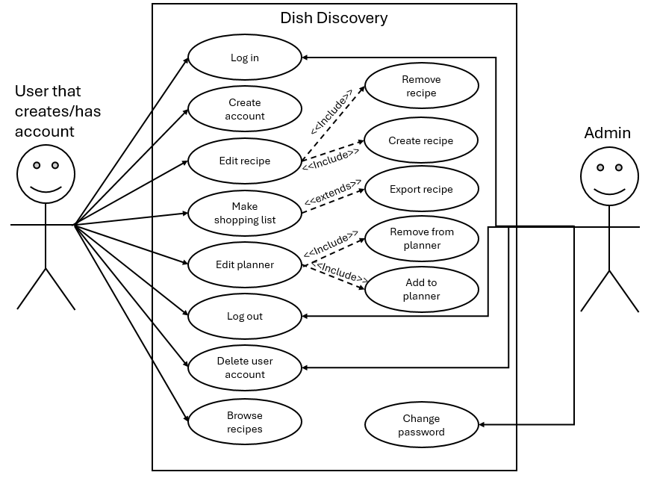

Figure 2. This is the use case diagram of the actions that the user will be able to carry out.

This is a use case diagram for the typical user and all the functions they will be able to complete. There is only one actor that is a normal user because users are only allowed to use the page once they are signed in. The aim is to keep the recipes private in the close community that is formed in the site. Each normal user will be able to access the same content. The admin actor is used to delete users and change passwords if needed. They will only have access to one page which displays user data.

### Login, Create Account and Log Out.

Both the users and administrators will need to log in to access the site using their username and password. To create an account a key will be needed so not everyone will be able to create an account and access the site. Users and administrators will both be able to log out of their account.

Administrators will not be able to create an account as this must be created to manage current users.

### Edit Recipes

Only the user will be able to edit recipes that they have made as it is their own recipe. This involves adding recipes and removing them if needed.

### Make Shopping List

The users will be able to make a shopping list and export it to show them the ingredients needed to make the meals in their planner.

### Delete User

Both the users and administrators will be able to remove user accounts. The users will only be able to remove their own accounts but administrators will be able to remove any user accounts when logged in.

### Browse Recipes

The users will be able to browse recipes that other users have created.

### Change Password

Administrators will be able to change user passwords if a user forgets theirs. This is a temporary measure to manage passwords.

# Related Materials

## BBC Food

Some sites are similar to this project: including the BBC Food that contains many recipes as well as a button that displays a shopping list (BBC, 2024). What makes this site different from this is that there will be options for users to add their recipes and share them with the few people who have access to the site.

A good function of the BBC Food website is that it is possible to create a detailed shopping list that separates the ingredients into categories to make shopping trips more efficient. While there is a shopping list, it doesn't allow the user to add multiple recipes to the list so they can get all the items they need in one shop (figure 3).

Figure 3. Screenshot of the shopping list created when selecting the shopping list button.

The site is easy to follow and is very informative when it comes to giving the user the information they need (figure 4). The layout of the site means that the site and recipes are both easy to follow and are very clear when trying to provide information.

Figure 4. These are the navigation tabs that are well labelled to ensure that the user knows what they are clicking on.

With the site being large and well-known, the amount of recipes and verified chefs means that there is a lot for the user to choose from. While it is good that only verified chefs can provide recipes, it also means that people aren’t allowed to share their own recipes for others to try.

Another good thing about this site is that users are able to save recipes they like in their “favourites” to look back on later if they have an account. This is useful for a site that provides a large number of recipes (figure 5).

The responsiveness of this site is good as the site is still functional and everything is still very clear. The navigation bar collapses down into a burger menu that can be easily accessed on a mobile device. The text and colour of the site are both clear making everything easy to read.

Figure 5. Example of recipes that have been added to the favourite items page.

## Simply Recipes And Relish

Another site that is similar to this project is “Simply Recipes” which provides users with a range of recipes made by verified cooks (Dotdash Meredith, 2024). They also use another site to create an online shopping list for the user called “Relish”. These sites provide a similar service to my project but require the user to use two separate sites instead of having it all in one place (Relish, 2024).

A good thing about Simply Recipes is that it look friendly and provides a nicer atmosphere compared to BBC Food. While the site looks nicer, there are some bad things when it comes to the site layout. The recipes are not shown in a uniform way and could confuse new users when trying to find a recipe (figure 6 and 7).

This website is very user-friendly when it comes to using it on a mobile device as this site is very responsive. The site looks clearer on a mobile device as everything is in a single column meaning that it is easy to scroll through.

Figure 6. A screenshot of the home page of simply recipes.

Figure 7. The recipes are not boxed in a uniform way and take up a large portion of the screen on some devices.

When looking at the recipes there is a large portion of text before the recipe which is a bit of a back story from the creator which is good but could put users off as the recipe isn’t readily available.

## Allrecipes

The final site that provides a similar service to my project is “Allrecipes”. They provide a range of recipes as well as short videos to show the user how to make the recipe with a visual aspect (Dotdash Meredith, 2024).

A good thing about this site is that they offer more than one form of media to show off the recipe. They add the typed out recipe along with pictures and videos for users to follow to help users that find it easier to follow instructions from a video rather than reading (figure 8).

Figure 8. A screenshot of the videos that are playable on the site.

Like Simply recipes, Allrecipes has some information before the recipe that takes up a large portion of the page which could put users off as they would want access to the recipe straight away. This could be put below the recipe for users that are interested so the users that just want the recipe can access the information they need to make their meal.

While this site is responsive like the other examples, there are some issues with the wrapping of text and image sizes. The banner at the top of the page does not shrink depending on screen size so some of the information is lost. The log in button also has text that wraps below on the login button. This could be better if it used a small thumbnail image or symbol to show that it is a login button. The news and trending section of the landing page has some of the text for the headlines cut off. This could be improved with the formatting of the cards they are displayed on.

# References

BBC. (2024, February). *BBC Food*. Retrieved from BBC Food: https://www.bbc.co.uk/food

Dotdash Meredith. (2024, February). *Allrecipes*. Retrieved from Allrecipes: https://www.allrecipes.com/

Dotdash Meredith. (2024, February). *Simply Recipes*. Retrieved from Simply Recipes: https://www.simplyrecipes.com/

Relish. (2024, February). *Relish*. Retrieved from Relish: https://www.relish.com/app/